Read Financial CSV with Parsed Dates
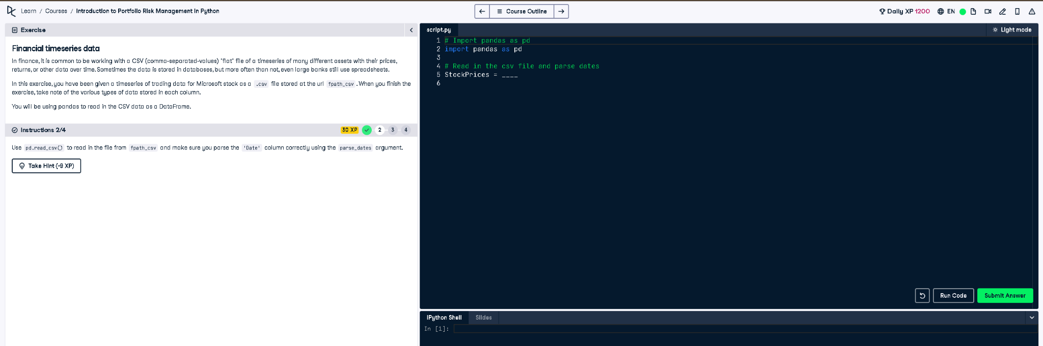

✅ Full Correct Answer:
# Import pandas as pd
import pandas as pd
# Read in the csv file and parse dates
StockPrices = pd.read_csv(fpath_csv, parse_dates=['Date'])

🧾 Explanation (Simple Words):
This code reads a CSV file that contains Microsoft stock trading data. The 'Date' column is automatically recognized as a date using parse_dates. This is helpful for accurate time series analysis and plotting later in the process.

